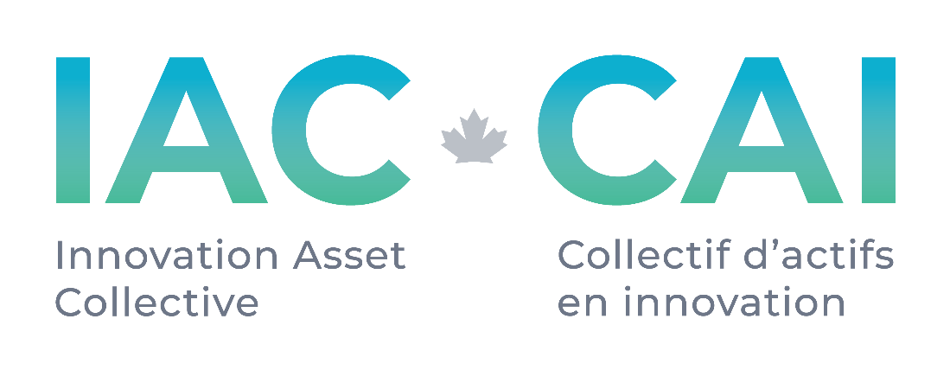

Request for Proposals
Patent Portfolio Valuation Services
# 006

Published: 24 November 2021
Deadline: open

Applications will be reviewed on a rolling basis as they are received.

Request for Proposal
1.0 About IAC
The Innovation Asset Collective (“IAC”) is a membership based registered not-for-profit organization with the mandate of assisting Canadian small and medium-sized enterprises (SMEs) in the data-driven clean technology (DDCT) sector to leverage intellectual property (IP) to compete and scale. Specifically, IAC’s core program offering for member companies (“Members”) includes assembling promising portfolios of patents to secure freedom to operate; providing Members with IP education and support in building their IP strategy to drive revenue growth through ownership of market differentiating innovation; granting funds to Members in support of implementing their IP strategy; and providing Members access to IAC’s market and patent research to inform strategic decisions. The goal for IAC is for Canadian cleantech SMEs is to be capable of maximizing the value of their intangible assets to succeed in Canada and beyond.
IAC is funded through a contribution from Innovation, Science and Economic Development Canada (ISED) to support innovation and the protection of Canadian
2.0 Background
For patent and patent portfolio acquisition and licensing activities within the FTO program which exceed a certain threshold, IAC has established extended criteria to enhance the value for money proposition safeguards. A fair market valuation of the IP assets is required by a third party to meet with policy rules.
3.0 Scope of Work
Inputs. IAC will provide:
- a list of the assets to be included in the valuation
- the acquisition opportunity review sheet which includes details of the family members including geographic coverage, asset expiration calculation, and market sector
- any evidence of use available
- market information as provided by seller
- per asset prior art research results

Outputs. Respondent expectations:
- First IP valuation model based on future projected cash flows related to the IP. Can be based on several financial models to be determined before project start. Model sensitivity parameters such as projected patented technology adoption rates/market growth, patent technology enabling factor, royalty rate and associated discount rate and life of the patents to be included. Microsoft Excel is preferred output format.
- Second IP valuation model based on recent actual third-party transactions of comparable intellectual property to determine a market price
- Microsoft Excel is preferred output format for models
- Summary report and expert insights and opinion

4.0 Proposal Information
Proposals to IAC in response to this RFP should include the following:
- Company name and address.
- Key Contact Information, including name(s), email, and phone number.
- Budget for completing deliverables listed in Scope of Work
- Areas of technical and market expertise
- List of market analysis tools and report subscriptions available to consultant
- A summary of the applicant’s background and qualifications as it relates to the Scope of Work as well as prior demonstrated experience in relation to IP and the IAC mandate (if applicable).
- Resume or CV of Key Contacts listed above
- The names and contacts of two references for work related in nature to the Scope of Work

5.0 Timeline
Patent valuation work depends on the size of the target portfolio and the nature of the analysis as described in the Scope of Work or a subset of that list. Timelines will be agreed upon on a per contract basis.
6.0 Evaluation Criteria
Submissions will be evaluated on the following criteria:
- Financial patent valuation capabilities.
  - Demonstrated background and industry experience delivering accurate patent portfolio models in multiple technology sectors.
  - Experience in data sciences and cleantech markets.
  - Access to market research (cost responsibility to be determined)
- Expanding the Ecosystem. We value relationships with individuals and firms who have supported our work in the past, but we are also committed to growing the IP ecosystem in Canada, and therefore also seeking to build our network of vendors and specialists across the country.
- Budget IAC will assess value for money of all projects. As IAC is funded by the Ministry of Innovation, Science and Economic Development, we have a responsibility to Canadian taxpayers in awarding contracts to maximize the value to IAC and its Members.

If you have questions about the process or any of the content in this RFP, please contact ckibjis@ipcollective.ca. IAC will respond to all questions received and share responses back with all interested applicants within 3 business days.

7.0 How to submit
Please submit your full applications by email to Colin Kibjis at ckibjis@ipcollective.ca by the deadline listed on the coversheet.
Applications will be reviewed on a rolling basis until an applicant is selected or the deadline.

