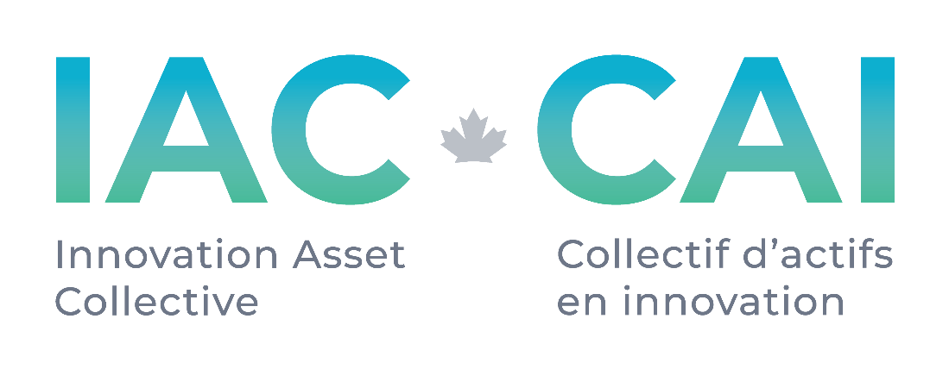

**Request for Proposals**

**Patent Portfolio Legal Review Services**

**# 005**

**Published: 24 November 2021**

**Deadline: open**

**Applications will be reviewed on a rolling basis as they are received.**

**Request for Proposal**

**1.0 About IAC**

The Innovation Asset Collective (“IAC”) is a membership based registered not-for-profit organization with the mandate of assisting Canadian small and medium-sized enterprises (SMEs) in the data-driven clean technology (DDCT) sector to leverage intellectual property (IP) to compete and scale. Specifically, IAC’s core program offering for member companies (“Members”) includes assembling promising portfolios of patents to secure freedom to operate; providing Members with IP education and support in building their IP strategy to drive revenue growth through ownership of market differentiating innovation; granting funds to Members in support of implementing their IP strategy; and providing Members access to IAC’s market and patent research to inform strategic decisions. The goal for IAC is for Canadian cleantech SMEs is to be capable of maximizing the value of their intangible assets to succeed in Canada and beyond.

IAC is funded through a contribution from Innovation, Science and Economic Development Canada (ISED) to support innovation and the protection of Canadian

**2.0 Background**

For patent and patent portfolio acquisition and licensing activities within the FTO program which exceed a certain threshold, IAC has established extended criteria to enhance the value for money proposition safeguards. Third party review of validity, patentable subject matter, and claim interpretation which possibly includes the assessment of infringement contentions is required by a legal entity to meet with policy rules.

**3.0 Scope of Work**

The interpretation of the scope of work for the legal review of a patent portfolio for the express purpose of satisfying the requirements of an acquisition or licensing effort by IAC requires some explicit description of the bounds of that effort. The following responsibilities may be excluded from the legal opinion RFP as they are within the capabilities of IAC:

* chain of title review
* check for any security interests publicly registered with the USPTO and CIPO
* review the maintenance fees paid based on the public record
* verifying asset maintenance fees are up to date
* verifying family member inclusion in the transaction
* verifying claim enablement
* asset litigation search
* prior art search

Included in scope by the respondent are:

* a review and comment on any anomaly identified by IAC in the preceding list.
* Patent prosecution history review and highlight any anomalies which may be substantive considering validity, patentability, and future use of the asset (i.e., defensive use, freedom to operate)
* Patent claim review and commentary on construction, interpretation issues based on unusual or unsupported lexicography or the like, antecedent issues, length, or any other potential validity problem
* Review and comment on prior art mappings provided by IAC

The depth of legal review of each patent portfolio will be constant as described above, but patent portfolios in scope will vary in number of assets being considered. Other variables include geographic distribution of assets, portfolio encumbrances, level of background disclosure, acquisition, or licence, etc. As such, quotation on this work is subject to the task at hand. It is left to the respondent to propose appropriate ways and means for a methodology for compensation.

**4.0 Proposal Information**

Proposals to IAC in response to this RFP should include the following:

* Company name and address.
* Key Contact Information, including name(s), email, and phone number.
* Budget formula for completing deliverables listed in Scope of Work
* A summary of the applicant’s background and qualifications as it relates to the Scope of Work as well as prior demonstrated experience in relation to IP and the IAC mandate (if applicable).
* Resume or CV of Key Contacts listed above
* The names and contacts of two references for work related in nature to the Scope of Work

**5.0 Timeline**

Legal patent review work depends on the size of the target portfolio and the nature of the analysis as described in the Scope of Work or a subset of that list. Timelines will be agreed upon on a per portfolio review basis.

**6.0 Evaluation Criteria**

Submissions will be evaluated on the following criteria:

* **Legal patent review services.**
* **Expanding the Ecosystem.** We value relationships with individuals and firms who have supported our work in the past, but we are also committed to growing the IP ecosystem in Canada, and therefore also seeking to build our network of vendors and specialists across the country.
* **Budget** IAC will assess value for money of all projects. As IAC is funded by the Ministry of Innovation, Science and Economic Development, we have a responsibility to Canadian taxpayers in awarding contracts to maximize the value to IAC and its Members.

If you have questions about the process or any of the content in this RFP, please contact [ckibjis@ipcollective.ca](mailto:ckibjis@ipcollective.ca). IAC will respond to all questions received and share responses back with all interested applicants within 3 business days.

**7.0 How to submit**

Please submit your full applications by email to Colin Kibjis at [ckibjis@ipcollective.ca](mailto:ckibjis@ipcollective.ca) by the deadline listed on the coversheet.

Applications will be reviewed on a rolling basis until an applicant is selected or the deadline.