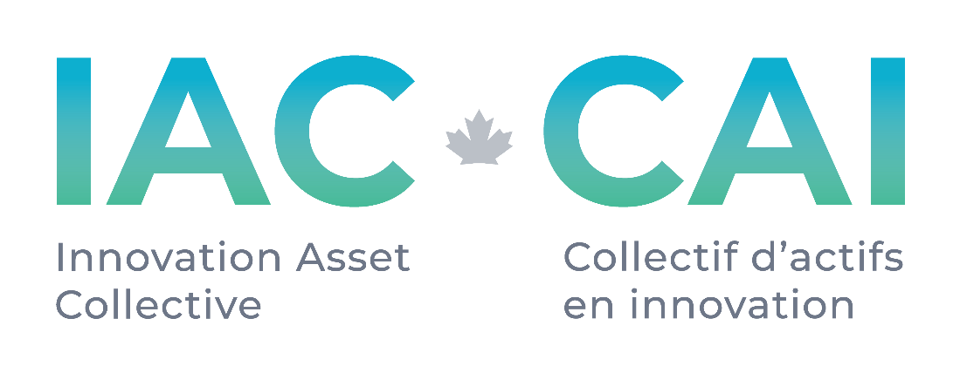

**Request for Proposals**

**Patent Analysis Services**

**# 004**

**Published: 24 November 2021**

**Deadline: open**

**Applications will be reviewed on a rolling basis as they are received.**

**Request for Proposal**

**1.0 About IAC**

The Innovation Asset Collective (“IAC”) is a membership based registered not-for-profit organization with the mandate of assisting Canadian small and medium-sized enterprises (SMEs) in the data-driven clean technology (DDCT) sector to leverage intellectual property (IP) to compete and scale. Specifically, IAC’s core program offering for member companies (“Members”) includes assembling promising portfolios of patents to secure freedom to operate; providing Members with IP education and support in building their IP strategy to drive revenue growth through ownership of market differentiating innovation; granting funds to Members in support of implementing their IP strategy; and providing Members access to IAC’s market and patent research to inform strategic decisions. The goal for IAC is for Canadian cleantech SMEs is to be capable of maximizing the value of their intangible assets to succeed in Canada and beyond.

IAC is funded through a contribution from Innovation, Science and Economic Development Canada (ISED) to support innovation and the protection of Canadian

**2.0 Background**

IAC is currently seeking to acquire and/or license patents to support its members in technology areas which provide a level of FTO and clearance. In general, data driven cleantech related patents are in scope, but assets which provide a defensive stance in certain circumstances are of interest in areas outside of cleantech as well. IAC has a pipeline of incoming acquisition and licensing opportunities which come from a variety of sources which include brokers, operating companies, inventors, academia and IAC Members. These opportunities include a variable number of patent families and technologies within the portfolios and follow a defined phased analysis approach.

The following Scope of Work describes analysis in various phases of the pipeline. It is anticipated that not all work items described are within the scope of capabilities of all respondents to this RFP. As such, it is important that the respondents include in detail, indicators of their respective areas of expertise with respect to section 3. Please note that the Scope of Work does **not** include legal opinion.

**3.0 Scope of Work**

1. Patent portfolio mining and evaluation indices
   1. applicability to Data Driven Clean Tech
   2. indication of use possible rating
   3. invention detectability
   4. is the patent enforceable
   5. geographic coverage rating
   6. defensive use possible
   7. market adoption
   8. continued prosecution potential
2. Portfolio applicability to Member landscapes
3. Claim construction evaluations
4. Claim enablement reviews
5. Prior art searches
6. Reverse engineering proposals
7. File history reviews

**4.0 Proposal Information**

Proposals to IAC in response to this RFP should include the following:

* Company name and address.
* Key Contact Information, including name(s), email, and phone number.
* Budget for completing deliverables listed in Scope of Work
* Areas of technical expertise
* List of analysis tools available to Consultant (Innography, PatSeer, Derwent etc.)
* A summary of the applicant’s background and qualifications as it relates to the Scope of Work as well as prior demonstrated experience in relation to IP and the IAC mandate (if applicable).
* Resume or CV of Key Contacts listed above
* The names and contacts of two references for work related in nature to the Scope of Work

**5.0 Timeline**

Patent analysis work depends on the size of the target portfolio and the nature of the analysis as described in the Scope of Work or a subset of that list. Timelines will be agreed upon on a per contract basis.

**6.0 Evaluation Criteria**

Submissions will be evaluated on the following criteria:

* **Technical patent analysis capabilities.** 
  + Analyze large patent portfolios to identify top patents to be considered for acquisition based on criteria including market information, technology trends, potential licensing value, and claim detectability.
  + Review and assess individual patents and patent claims for quality in view of legal, technological, and licensing value, to help identify top patents for acquisition or licensing.
  + Diverse technical knowledge in data-driven technologies
  + Large patent portfolio analysis experience
  + Strong understanding of patents: the drafting aspects, claim detectability, validity, infringement, FTO and licensing concepts
  + Experience producing claim charts to document infringement, and detecting issues with regards to the claims and infringement read
  + Strong knowledge of the Patent System (Patent Laws and Rules in various jurisdictions)
  + Reverse engineering experience, including defining testing parameters to detect claim infringement
* **Expanding the Ecosystem.** We value relationships with individuals and firms who have supported our work in the past, but we are also committed to growing the IP ecosystem in Canada, and therefore also seeking to build our network of vendors and specialists across the country.
* **Budget** IAC will assess value for money of all projects. As IAC is funded by the Ministry of Innovation, Science and Economic Development, we have a responsibility to Canadian taxpayers in awarding contracts to maximize the value to IAC and its Members.

If you have questions about the process or any of the content in this RFP, please contact [ckibjis@ipcollective.ca](mailto:ckibjis@ipcollective.ca). IAC will respond to all questions received and share responses back with all interested applicants within 3 business days.

**7.0 How to submit**

Please submit your full applications by email to Colin Kibjis at [ckibjis@ipcollective.ca](mailto:ckibjis@ipcollective.ca) by the deadline listed on the coversheet.

Applications will be reviewed on a rolling basis until an applicant is selected or the deadline.